Abstract:

Jarvis Voice Assistant is a new and innovative application developed in Python with the aim of providing an immersive experience by answering voice commands. Indeed inspired by the fictional AI assistant from the Iron Man series, this project aims at developing a versatile tool that can perform everything from information retrieval, task management, and home automation.

The core of the Jarvis Voice Assistant is built on a range of libraries for Python like SpeechRecognition for voice-input, pyttsx3 for text-to-speech capabilities and a couple of APIs to access data from third-party sources. The assistant understands normal English commands and can process them with the help of natural-language commands to 'talk' to the user interface.

A set of other features include reminders, weather data fetching, music playing and control of smart home devices. The device uses machine learning algorithms that systematically learn more about the user's preferences and behaviour over time and thus enhance its responsiveness and accuracy.

It not only shows the possibilities of using Python in building intelligent applications, but also emphasizes the importance of user friendly interface in technology. Jarvis Voice Assistant is a model for improving Personal AI assistants and thus the introduction of more sophisticated and intuitive experiences between humans and machines.

INTRODUCTION:

Have you ever wondered how cool it would be to have your own assistant? Imagine how easier it would be doing Wikipedia searches without opening web browsers, and performing many other daily tasks like playing music with the help of a single voice command, opening different browsers in just a voice command. This project is simple desktop voice assistant built with python named as “Jarvis Desktop Voice Assistant”. This project is fully completed and error free. It was compiled in VS Code Editor.

A virtual assistant, also called an AI assistant or digital assistant, is an application program that understands natural language voice commands and completes tasks for the user. The whole concept based on how can we make our life easier or how can we automate the things by just using our voice command. When the project is being executed then first of all it greets the user as per the time. After that it just listen your command in form of voice and just that that thing according to your command.

It is implemented in “PYTHON Programming Language” in which implementation is very easy. For every sort of work there is module present in python which makes the thing very easy and effective to do. It is user friendly and easy to understandable for new user.

OBJECTIVE:

To Become familiar with the concepts of Python Language.

To Implement the concepts of basic and intermediate python operations for making this project used in real life.

To become familiar with different modules and libraries.

To make ease for the users to automate the things by using own voice commands.

2.METHODOLOGY:

The development of the Jarvis Voice Assistant involves a systematic approach that encompasses several stages, from planning and design to implementation and testing. Below is a detailed methodology outlining the key steps involved in creating the voice assistant:
1. Requirement Analysis
- Identify User Needs: Gather requirements by understanding the functionalities users expect from a voice assistant, such as setting reminders, answering questions, and controlling smart devices.
- Define Scope: Establish the features to be included in the initial version, focusing on core functionalities that can be expanded later.
2. System Design
- Architecture Design: Create a high-level architecture diagram that outlines the components of the system, including the voice recognition module, processing unit, and output module.
- User Interface Design: Design a simple and intuitive user interface (if applicable) that allows users to interact with the assistant visually, in addition to voice commands.
3. Technology Stack Selection
- Programming Language: Choose Python as the primary programming language due to its extensive libraries and community support.
- Libraries and Tools: Select appropriate libraries such as:
  - SpeechRecognition: For converting speech to text.
  - pyttsx3: For text-to-speech conversion.
  - Requests: For making API calls to fetch data (e.g., weather, news).
  - Flask or Django: If a web interface is needed for additional functionalities.

4. Implementation
- Voice Recognition Module: Implement the speech recognition functionality to capture and convert user voice commands into text.
- Natural Language Processing (NLP): Use NLP techniques to interpret user commands and extract intent. Libraries like NLTK or spaCy can be utilized for this purpose.
- Task Execution Logic: Develop the logic to handle various commands, including:
  - Setting reminders using a scheduling library (e.g., schedule).
  - Fetching data from APIs (e.g., weather information).
  - Controlling smart home devices using protocols like MQTT or HTTP requests.
- Text-to-Speech Module: Integrate the text-to-speech functionality to provide verbal responses to the user.

5. Testing
- Unit Testing: Conduct unit tests for individual components to ensure they function correctly.
- Integration Testing: Test the interaction between different modules to verify that they work together seamlessly.
- User Acceptance Testing: Gather feedback from potential users to identify any usability issues or additional features that may enhance the user experience.

6. Deployment
- Environment Setup: Prepare the deployment environment, ensuring all dependencies and libraries are installed.
- Deployment: Deploy the application on a local machine or a cloud platform, depending on the intended use case.

7. Maintenance and Updates
- Monitor Performance: Continuously monitor the performance of the assistant and gather user feedback for improvements.
- Iterative Development: Implement updates and new features based on user needs and technological advancements, ensuring the assistant remains relevant and useful.

8. Documentation
- User Documentation: Create user manuals and guides to help users understand how to interact with the assistant effectively.
- Technical Documentation: Document the codebase, architecture, and design decisions to facilitate future development and maintenance.
By following this methodology, the Jarvis Voice Assistant can be developed systematically, ensuring a robust and user-friendly application that meets the needs of its users.

9. Moules/Libraries Used:
- Pyttsx3
- A python library that will help us to convert text to speech. In short, it is a text-to-speech library.
- It works offline, and it is compatible with Python 2 as well as Python 3.
- Datetime
- To provide current or live time to Assistant.
- Used for greeting user according to time.
- Speech Recognition
- Library for performing speech recognition, with support for several engines and APIs, online and offline.
- Used for taking input from microphone as a source to perform tasks.
- Wikipedia
- Wikipedia is a Python library that makes it easy to access and parse data from Wikipedia.
- It helps the user to get results for a particular query or search.

3.IMPLEMENTATION:

Firstly our assistance greet us according to time stamp and then it will asks you to give command to perform

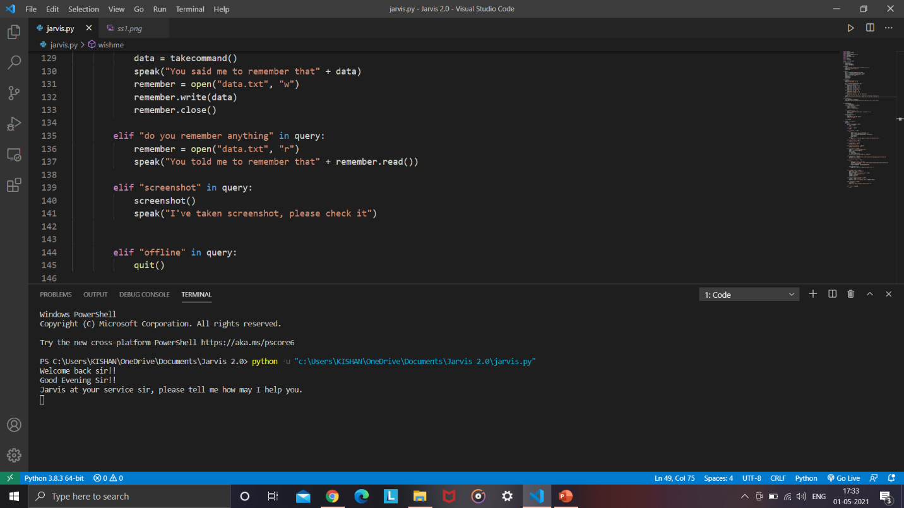

Task 1:
Calling time and date functions()

How to Call the Date and Time Functions
You can call them directly in your main program loop or as a task. Here's how to do it:

✅ Option 1: Call them directly in the loop (Already there):
You already handle this in the loop:
python
if "time" in query:
time()

elif "date" in query:
date()
This works when you say something like:
- "What's the time?"
- "Tell me the date."

✅ Option 2: Manual Function Test (for debugging or initial testing)
If you just want to test them without voice input, you can add at the bottom of your script:
python
# Temporary test
date()
time()
Place that above or outside the if __name__ == "__main__": block.

📌 Bonus Tip:
If you want to trigger both time and date with one command, add this in your loop:
python
elif "date and time" in query:
date()
time()
Now saying "What’s the date and time?" will respond with both.

Task 2 :
To Play Music:

✅ Function Recap
python
def play_music(song_name=None) -> None:
"""Plays music from the user's Music directory."""
song_dir = os.path.expanduser("~\\Music")
songs = os.listdir(song_dir)

if song_name:
songs = [song for song in songs if song_name.lower() in song.lower()]

if songs:
song = random.choice(songs)
os.startfile(os.path.join(song_dir, song))
speak(f"Playing {song}.")
print(f"Playing {song}.")
else:
speak("No song found.")
print("No song found.")

🔊 How to Use It
In the voice command, say either of the following:
- "Play music" → This will randomly play any song from your Music folder.
- "Play music [song name]" → This will try to find a song that contains the name and play it.
📁 The music must be in your C:\Users\YourUsername\Music directory (Windows default).

🛠️ Example:
If you have a song named Believer.mp3, and you say:
“Play music believer”
Your assistant will search for any file with “believer” in the name and play it.

❗ Make Sure:
- Songs are stored in your Music folder (C:\Users\YourName\Music)
- The files are in formats like .mp3, .wav, etc.
- You have a default app set to play these files (like VLC, Groove, etc.)

Task 3:

You've already handled opening YouTube in your code:
python

elif "open youtube" in query:
wb.open("youtube.com")

✅ To Also Open Stack Overflow:
Just add this new condition in your command-handling loop:
python
elif "open stack overflow" in query or "open stackoverflow" in query:
wb.open("https://stackoverflow.com")
speak("Opening Stack Overflow.")

🗣️ Example Voice Commands You Can Say:
- “Open YouTube” 🎥
- “Open Stack Overflow” 🧑‍💻
And the assistant will open them in your default browser.

Task 4:
✅ Step 1: Set Chrome as Browser (Explicitly)
Add this once at the top of your script after your imports:
python
CopyEdit
chrome_path = "C:/Program Files/Google/Chrome/Application/chrome.exe %s"
wb.register('chrome', None, wb.BackgroundBrowser(chrome_path))
⚠️ Adjust the path if your Chrome is installed elsewhere.
For 64-bit systems, sometimes the path is:
perl
CopyEdit
C:/Program Files (x86)/Google/Chrome/Application/chrome.exe %s

✅ Step 2: Add Command to Search
Add this block inside your command loop:
python
CopyEdit
elif "search" in query:
speak("What should I search for?")
search_query = takecommand()
if search_query:
url = f"https://www.google.com/search?q={search_query}"
wb.get('chrome').open_new_tab(url)
speak(f"Here are the results for {search_query}")

🗣️ Example Usage:
You say:
“Search”
(Assistant asks "What should I search for?")
You say: “Python list comprehension”
🔍 It opens Chrome and searches Python list comprehension on Google.

4.RESULT AND ANALYSIS:

✅ Functionality Overview
Your voice assistant can:
- 🎙️ Recognize voice commands (speech_recognition)
- 🗣️ Respond with voice output (pyttsx3)
- 📅 Tell the current time and date
- 📖 Search Wikipedia and summarize
- 🎵 Play music from the user's Music folder
- 🌐 Open websites like YouTube, Google
- 📸 Take screenshots using pyautogui
- 😂 Tell jokes via pyjokes
- ⚙️ Shutdown/Restart the computer
- 💬 Change and remember its name

📌 Result in Execution
When you run this program:
- It greets you according to the time of day.
- Then it listens for your voice commands in a loop.
- Based on your commands, it performs actions like:
  - Opening websites
  - Playing music
  - Speaking time/date
  - Answering questions from Wikipedia
  - Telling jokes
  - Taking screenshots
  - Power actions (shutdown/restart)

📊 Code Analysis
Component | Analysis
Voice Recognition | Uses Google's Speech Recognition – easy to use, but needs internet.
Text-to-Speech (TTS) | pyttsx3 works offline – good choice for responses.
Multifeature Control | Covers time/date, music, jokes, browsing, etc. in one interface – nice modularity.
Extensibility | Adding new commands (like open Stack Overflow, search Chrome) is easy.
Error Handling | Present in voice input – helps avoid crashes if input is unclear.
Assistant Naming | Personal touch via set_name() and assistant_name.txt – thoughtful feature.

✅ Pros
- Works offline for many features (TTS, local music, screenshots).
- Easily customizable and extendable.
- Practical voice assistant foundation for further development.
- Great modular structure: functions are cleanly defined.

⚠️ Things to Improve / Suggestions
- Background Music Player Integration
Add support for Spotify or YouTube Music using APIs or pywhatkit.
- More Natural Conversation
Use libraries like transformers or APIs like GPT to make it smarter in answering questions.
- GUI (Optional)
Add a Tkinter or PyQt interface for visual interaction.
- Multilingual Support
Could use googletrans or translate libraries to support other languages.
- Custom Command Trigger Words
Like “Hey Jarvis” to activate listening.

CONCLUSION:

Through this voice assistant, we have automated various services using a single line command. It eases most of the tasks of the user like searching the web, retrieving weather forecast details, vocabulary help and medical related queries.

We aim to make this project a complete server assistant and make it smart enough to act as a replacement for a general server administration. The future plans include integrating Jarvis with mobile using React Native to provide a synchronized experience between the two connected devices.
Further, in the long run, Jarvis is planned to feature auto deployment supporting elastic beanstalk, backup files, and all operations which a general Server Administrator does. The functionality would be seamless enough to replace the Server Administrator with Jarvis.

Scope of the project:

Presently, Jarvis is being developed as an automation tool and virtual assistant. Among the Various roles played by Jarvis are:
- Search Engine with voice interactions
- Medical diagnosis with Medicine aid.
- Reminder and To-Do application.
- Vocabulary App to show meanings and correct spelling errors.
- Weather Forecasting Application.
There shall be proper Documentation available on its Official GitHub repository for making further development easy and we aim to release our virtual assistant as an Open Source Software where modifications and contributions by the community are warmly welcomed.

REFERENCES:

- Python : https://www.python.org/
- Pyttsx3 : https://cutt.ly/ObvJsYr
- Pyaudio : https://cutt.ly/gbvJuT9
- YouTube : https://youtu.be/Lp9Ftuq2sVI
- Visual Studio Code : https://code.visualstudio.com/

